

1



### Faculty of Science and Technology

**PROJECT NAME**: Café Management System

**Course:** Object Oriented Programming 2

**Group Members:**

|  |  |
| --- | --- |
| **ID** | **NAME** |
| 18-36897-1 | MAHADI, M. MINHAZ |
| 18-39066-3 | MD.KABBIR HASAN |
| 19-41534-3 | SHARON BHOUMIK |
|  |  |

2



## Table of Contents

|  |  |  |
| --- | --- | --- |
| **No** | **Topic** | **Page No** |
| 01 | **System summary** | 3 |
| 02 | **Use case diagram** | 3 |
| 03 | **Class diagrams of the system** | 5 |
| 04 | **Activity diagram** | 6 |
| 05 | **ERD diagram** | 7 |



3

**System Summary**

This system is about café management system. We have admins, café admins management and users. We have created database for these actors. This is actually an administrative site. In this site the admins are the real-owners of the system. under this system there can be multiple restaurants. Each restaurant has their own restaurant admin who is the local head of that particular branch. Under each restaurant admin there will be employees of different positions. such as cleaner, waiter, cook. The main of this system can add any restaurant to the database as restaurant admin. Means every restaurant admin represents acafe. An admin can add, delete and update the information of all type of workers in the system. The cafe admin can add employees to their restaurant database under any particular admin. Each region is managed by one admin. The employees can register to the system by it can only be granted by the restaurant admin themselves. Admins, restaurant admins, management all can update their profiles and change their account password. If anyone forgets password there is a process to generate random password to log in to the system. As this is an administrative website there will be no food ordering or public service.

## Use Case Diagram

### Scenario:

This is the use case diagram of RMS cafe administrative system. We have. of types of actors, Admin, café admin, management. Management can register under any particular restaurant admin, can update his/ her profile, the Café admin will accept or decline any registration request A restaurant - admin cam manually add/ delete

/update any managements profile. Admin has the power to add, delete of update any restaurant admins profile. As an admin is an administrative actor, they can also add/delete /update management. Only admin Lay the power I see the personal info’s of Cafeadmin and management such as password.



4

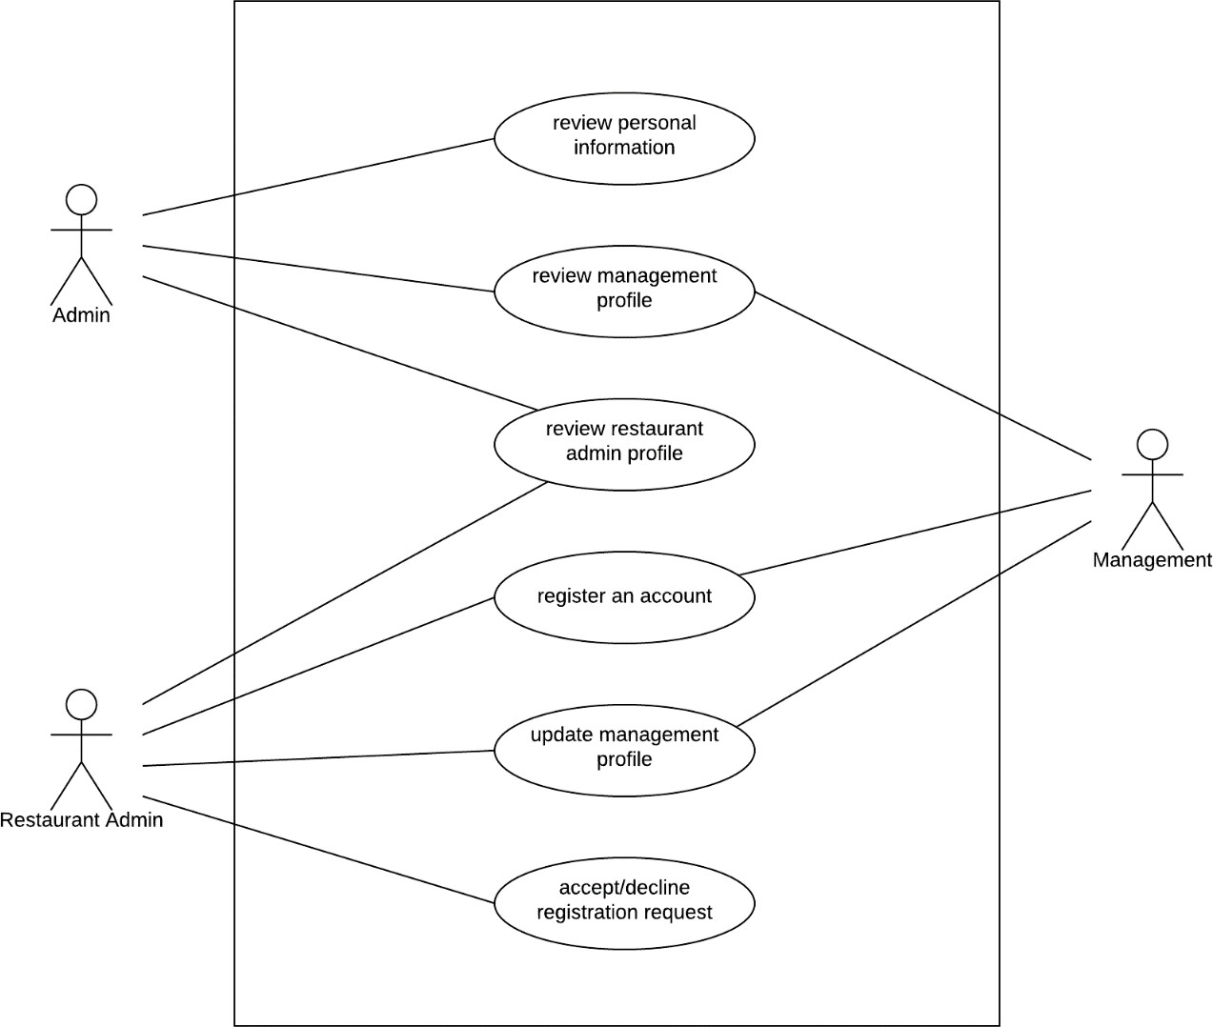

**Fig: Use Case Diagram**

5



## Class Diagram

### Scenario:

There are four class in our system which are restaurant, admin, restaurant admin and management. Restaurant have its ID which is integer, Name which is string, location which is string, phone which is string, type which is string and all of them are private. There are 2 operations for restaurant class and all of them are public and their return type are void. Which are connectToAdmin and ConnectToRestaurantAdmin. Admin class has its ID which is integer and Name which is string. And both of them are private. There are 3 operations in Admin class and all of them are public and their return type are void. Which are manageManagement, manageRestaurantAdmin, managePersonalInfo. For Restaurant Admin there is a private integer attribute called ID and string attribute called Name. There are 4 operations in Restaurant Admin class and all of them are public. The operation names are manageProfile, manageManagement, registerAccount, accept/deleteRequest. For Management class there is a private integer attribute called ID and string attribute called Name. There are 3 operations in management class and all of them are public. The operation names are manageProfile, registerAccount, updateProfile. Restaurant can connect more than one Admin and Restaurant can connect one Restaurant Admin at a time. Admin can manage more than one Management and Admin can manage more than one Restaurant Admin at a time. Restaurant Admin can management more than one management.

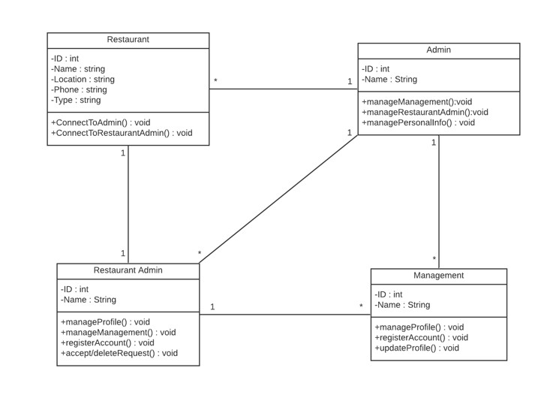

6

### Fig: Class Diagram

**Activity Diagram**

**Scenario:**

After starting the process customer need to register first. If the registration request approved by admin customer can login their account. customer have to provide information which will be stored by system.

For online order customer can ask for food information. If food is available food will be added on cart and payment gateway will be open for payment. After getting payment status will be updated. For the off-line order food will be served by employee. After receiving food customer will pay physically and payment status will be updated by admin.



7

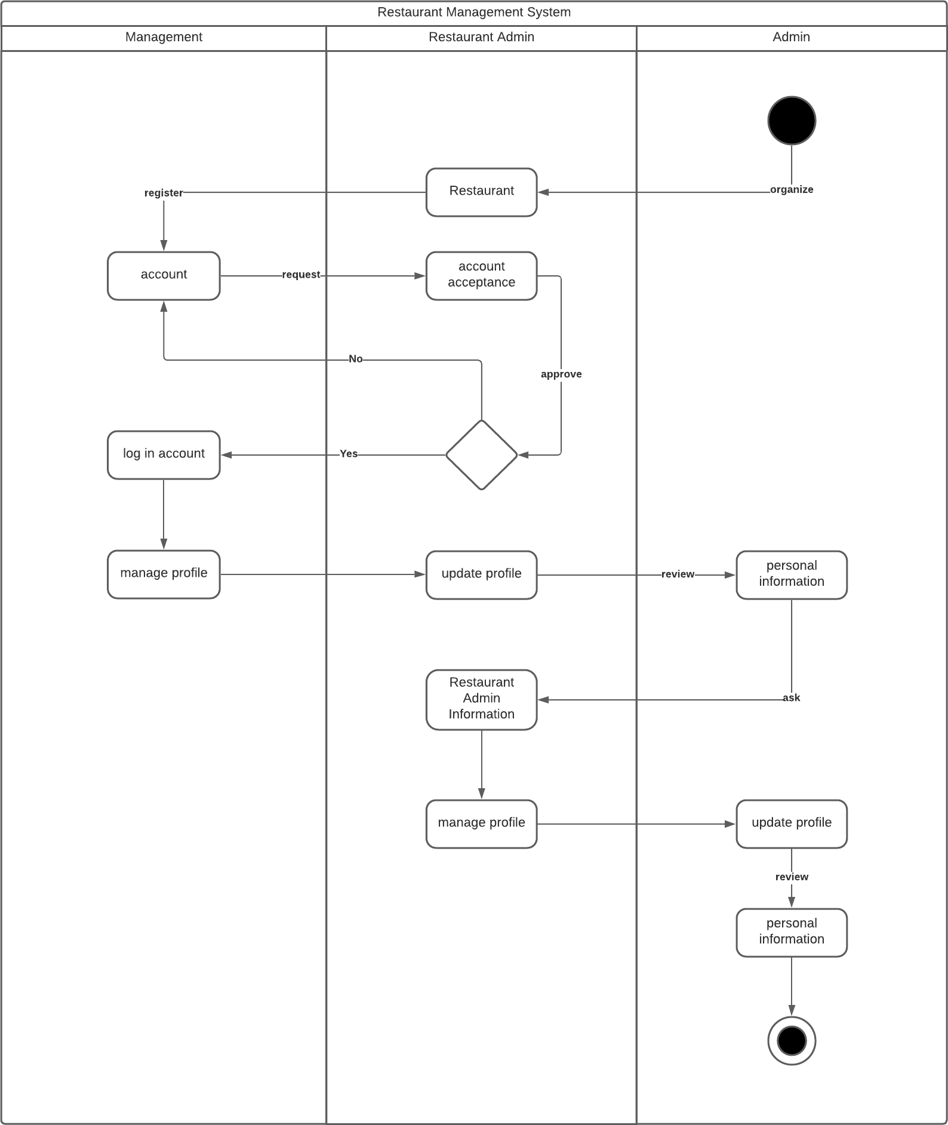

### Fig: Activity Diagram



8

**ER Diagram**

**Scenario:**

Admin have email, admin name, NID, password, admin_id and phone here email and phone are multivalued. Restaurant Admin have Location, NID, Restaurant_id(primary key), email, Restaurant admin name here email and location are multivalued. User have user_id (primary key), email, NID, phone, password, location here phone, location and email have multivalued. Management have worker_type, worker_id, email, phone, NID here email and phone are multivalued. Admin can verify the user and restaurant admin. Management can manages user. Restaurant admin can manipulate the management.

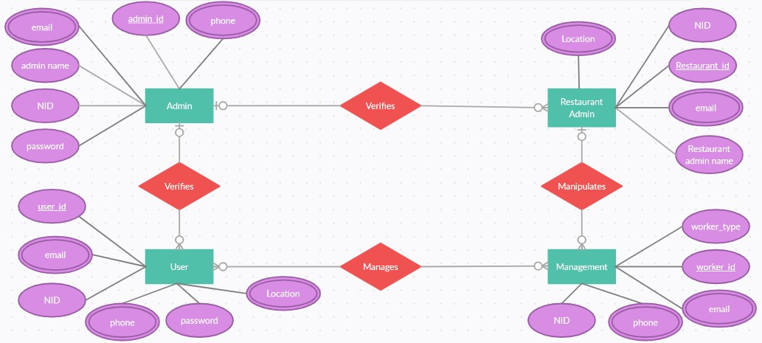

### Fig: ER Diagram



9

**Schema Diagram**

**Scenario:**

In schema diagram there are nine tables with different entity and their attributes. They are restaurant, admin, email, location, phone, restaurant admin, management, user management & user. The attributes of restaurants are restaurant name, address, phone. The attributes of admin details are a_id, a_name, a_password, a_purl, e_id. p_id. The attributes of email are e_id e_email. The attributes of Location are l_id & l_location. The attributes of phone are p_ID, p_phone. The attributes of user are u_id, u_name, u_password, u_nid, u_purl, e_id, p_id, l_id, a_id. The attributes of user management are u_id & w_id . The attributes of management are w_id, w_type, w_password, w_nid, w_purl, e_id, p_id & r_id. The attributes of restaurant admin are r_id, r_name, r_password, r_NID, r_purl, e_id, l_id, a_id.

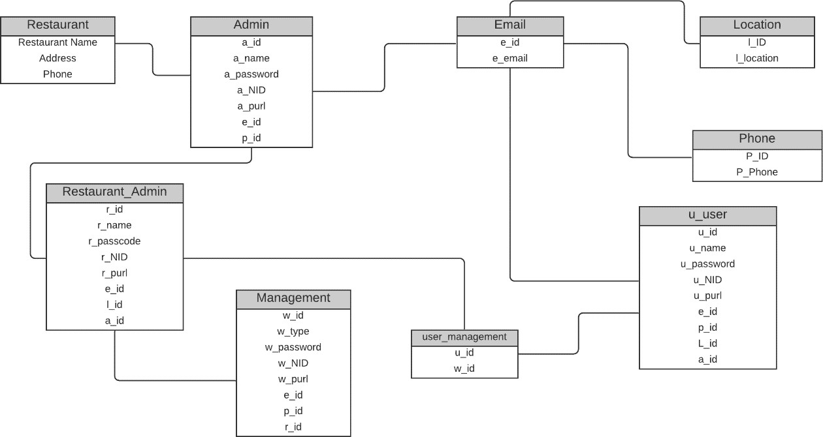

## Fig: Schema Diagram

10



# Sample Data

